DIABETIC RETINOPATHY USING CNN
ABSTRACT:
Diabetic Retinopathy (DR) is an eye disease associated with chronic diabetes. DR is the leading cause of blindness among working aged adults around the world and estimated it may affect more than 93 million people. Progression to vision impairment can be slowed or controlled if DR is detected in time, however this can be difficult as the disease often shows few symptoms until it is too late to provide effective treatment. Currently, detecting DR is a time-consuming and manual process, which requires an ophthalmologist or trained clinician to examine and evaluate digital color fundus photographs of the retina, to identify DR by the presence of lesions associated with the vascular abnormalities caused by the disease. The automated method of DR screening will speed up the detection and decision-making process, which will help to control or manage DR progression. This paper presents an automated classification system, in which it analyzes fundus images with varying illumination and fields of view and generates a severity grade for diabetic retinopathy (DR) using deep learning models such as GAN(general adversarial neural network).
INTRODUCTION:
Retinal vessel segmentation are the implementation of screening programs for diabetic retinopathy, evaluation of the retinopathy of prematurity, detection of macular a vascular regions, detection of arteriolar narrowing, measurement of vessel tortuosity to characterize hypertensive retinopathy, measurement of vessel diameter to diagnose hypertension, cardiovascular diseases, and computer-assisted laser surgery. Other indirect applications include automatic generation of retinal maps for the treatment of age-related macular degeneration, extraction of characteristic points of the retinal vasculature for temporal or multimodal image registration, retinal image mosaic synthesis, identification of the optic disc position, and localization of the fovea. Furthermore, the network of retinal vessels is distinctive enough to each individual and can be used for biometric identification, although it has not yet been extensively explored. Vessels, fovea, and optical disk are the three most important structures of the human retina and are mostly used for several applications, such as retinal image registration, illumination correction, as well as pathology detection inside the retina. Detection of these important structures manually is time consuming and depends on the expertise of the user. The segmentation of blood vessels from fundus photographs can be difficult for a number of reasons. Some of the corrupting sources are related to the acquisition process and kind of imagery, and others are intrinsic features of retinal images. The two most influential factors that make the segmentation difficult are the improper retinal image contrast and the uneven background illumination. The uneven illumination is from the acquisition process, while the unsuitable contrast is from the acquisition process and the fact that different vessels have different contrast with background. In other words, arteries have higher contrast than veins. Thick vessels also display a higher contrast with the background than do thin ones. Moreover, presence of noise, fovea and optical disk as well as vessels with various widths, effects of lesions, and pathological changes are the other cases to be considered. Therefore, presence of an automatic blood vessel detection tool that segments the blood vessels of retina in a short time and with high accuracy is our desire. Many efforts have been made and various methods have been introduced in order to segment retinal images. The algorithms in this field fall in three groups: window-based, classifier-based, and tracking-based approaches. The Window-based methods, such as edge detection, estimate a match at each pixel for a given model against the pixel’s surrounding window. The cross section of a vessel in a retinal image was modeled by a Gaussian-shaped curve and then detected using rotated matched filters. Classifier-based methods perform in two stages. First, a low-level algorithm produces a segmentation of spatially connected regions. These candidate regions are then classified as being vessel or not vessel. Tracking-based methods utilize a profile model to incrementally step along and segment a vessel. In order to start tracking, there is a need for seed points. Generally, there are two approaches to select the seed points: manually selecting seeds, which is labor intensive and depends on the expertise of the user, and automatically selecting seeds. Proposed a method in which the ridges are detected by checking the zero-crossing of the gradients and the curvature; tracking starts from the seed with the highest intensity. Vessel segments, which are shorter than a given threshold or shorter than 30 pixels and with a height-to-width ratio bigger than a given threshold, are removed. In this paper, a method based on using curvelet transform is proposed to enhance and prepare the retinal image for better vessel detection. In the past decade, introduced the curvelet transform, a new multiscale transform. Curvelet as a geometrical transform has two important features: anisotropy scaling law and the directionality. These two features made curvelet capable of sparse representation and handling image singularities better than other multiscale transforms
SOFTWARE REQUIREMENTS
Python: Python Is An Object-Oriented, High Level Language, Interpreted, Dynamic And Multipurpose Programming Language.
Python Is Easy To Learn Yet Powerful And Versatile Scripting Language Which Makes It Attractive For Application Development.
Python's Syntax And Dynamic Typing With Its Interpreted Nature, Make It An Ideal Language For Scripting And Rapid Application Development In Many Areas.
Python Supports Multiple Programming Pattern, Including Object Oriented Programming, Imperative And Functional Programming Or Procedural Styles.
Python Is Not Intended To Work On Special Area Such As Web Programming. That Is Why It Is Known As Multipurpose Because It Can Be Used With Web, Enterprise, 3d Cad Etc.
We Don't Need To Use Data Types To Declare Variable Because It Is Dynamically Typed So We Can Write A=10 To Declare An Integer Value In A Variable.
Python Makes The Development And Debugging Fast Because There Is No Compilation Step Included In Python Development And Edit-Test-Debug Cycle Is Very Fast.
2. Python Features

1) Easy To Use:
Python Is Easy To Very Easy To Use And High Level Language. Thus It Is Programmer-Friendly Language.

2) Expressive Language:
Python Language Is More Expressive. The Sense Of Expressive Is The Code Is Easily Understandable.

3) Interpreted Language:
Python Is An Interpreted Language I.E. Interpreter Executes The Code Line By Line At A Time. This Makes Debugging Easy And Thus Suitable For Beginners.

4) Cross-Platform Language:
Python Can Run Equally On Different Platforms Such As Windows, Linux, Unix , Macintosh Etc. Thus, Python Is A Portable Language.

5) Free And Open Source:
Python Language Is Freely Available(Www.Python.Org).The Source-Code Is Also Available. Therefore It Is Open Source.

6) Object-Oriented Language:
Python Supports Object Oriented Language. Concept Of Classes And Objects Comes Into Existence.

7) Extensible:
It Implies That Other Languages Such As C/C++ Can Be Used To Compile The Code And Thus It Can Be Used Further In Your Python Code.

8) Large Standard Library:
Python Has A Large And Broad Library.

9) Gui Programming:
Graphical User Interfaces Can Be Developed Using Python.

10) Integrated:
It Can Be Easily Integrated With Languages Like C, C++, Java Etc.

3. Python History
- Python Laid Its Foundation In The Late 1980s.
- The Implementation Of Python Was Started In The December 1989 By Guido Van Rossum At Cwi In Netherland.
- Abc Programming Language Is Said To Be The Predecessor Of Python Language Which Was Capable Of Exception Handling And Interfacing With Amoeba Operating System.
- Python Is Influenced By Programming Languages Like:
  - Abc Language.
  - Modula-3

5. Python Applications
Python As A Whole Can Be Used In Any Sphere Of Development.
Let Us See What Are The Major Regions Where Python Proves To Be Handy.

1) Console Based Application
Python Can Be Used To Develop Console Based Applications. For Example: Ipython.

2) Audio Or Video Based Applications
Python Proves Handy In Multimedia Section. Some Of Real Applications Are: Timplayer, Cplay Etc.

3) 3d Cad Applications
Fandango Is A Real Application Which Provides Full Features Of Cad.

4) Web Applications
Python Can Also Be Used To Develop Web Based Application. Some Important Developments Are: Pythonwikiengines, Pocoo, Pythonblogsoftware Etc.

5) Enterprise Applications
Python Can Be Used To Create Applications Which Can Be Used Within An Enterprise Or An Organization. Some Real Time Applications Are: Openerp, Tryton, Picalo Etc.

6) Applications For Images
Using Python Several Application Can Be Developed For Image. Applications Developed Are: Vpython, Gogh, Imgseek Etc.
There Are Several Such Applications Which Can Be Developed Using Python

6. Python Example
Python Code Is Simple And Easy To Run. Here Is A Simple Python Code That Will Print "Welcome To Python".
A Simple Python Example Is Given Below.
- >>> A="Welcome To Python"
- >>> Print A
- Welcome To Python
- >>>
Explanation:
- Here We Are Using Idle To Write The Python Code. Detail Explanation To Run Code Is Given In Execute Python Section.
- A Variable Is Defined Named "A" Which Holds "Welcome To Python".
- "Print" Statement Is Used To Print The Content. Therefore "Print A" Statement Will Print The Content Of The Variable. Therefore, The Output "Welcome To Python" Is Produced.

Python 3.4 Example
In Python 3.4 Version, You Need To Add Parenthesis () In A String Code To Print It.
- >>> A=("Welcome To Python Example")
- >>> Print A
- Welcome To Python Example
- >>>

7. How To Execute Python

7. How To Execute Python
There Are Three Different Ways Of Working In Python:

1) Interactive Mode:
You Can Enter Python In The Command Prompt And Start Working With Python.
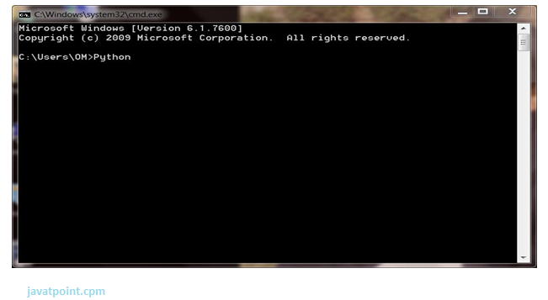
Press Enter Key And The Command Prompt Will Appear Like:
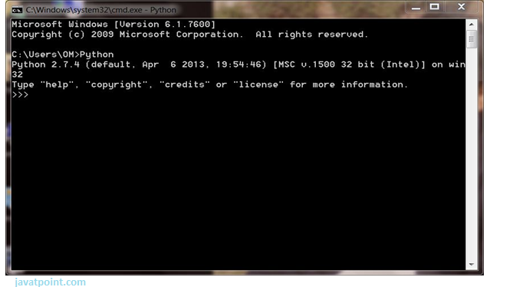
Now You Can Execute Your Python Commands.
Eg:
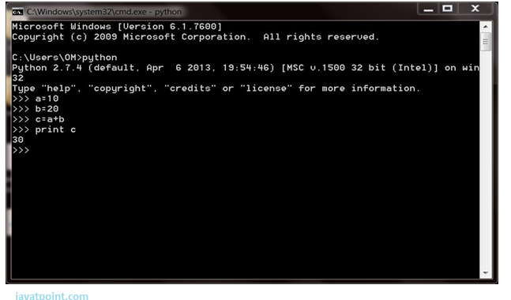

2) Script Mode:
Using Script Mode , You Can Write Your Python Code In A Separate File Using Any Editor Of Your Operating System.
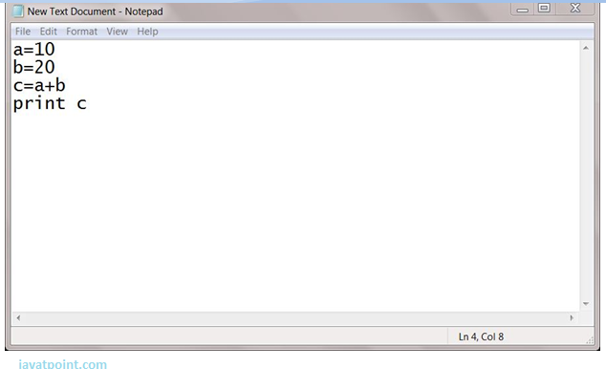
Save It By .Py Extension.
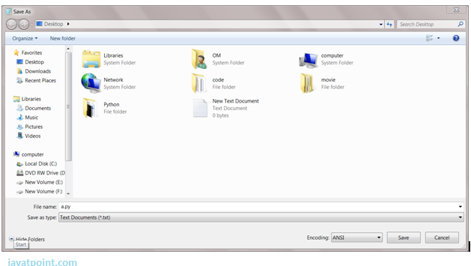
Now Open Command Prompt And Execute It By :
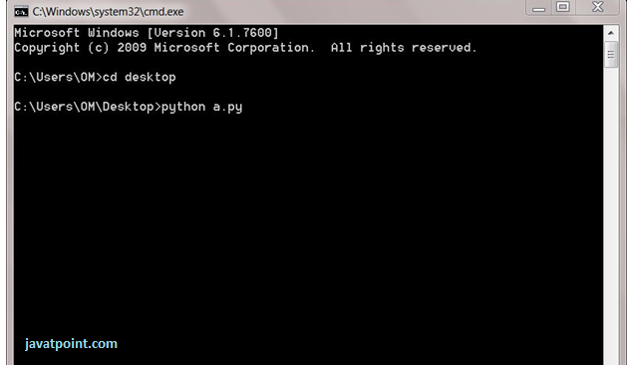
Note: Path In The Command Prompt Should Be Where You Have Saved Your File. In The Above Case File Should Be Saved At Desktop.

3) Using Ide: (Integrated Development Environment)
You Can Execute Your Python Code Using A Graphical User Interface (Gui).
All You Need To Do Is:
Click On Start Button -> All Programs -> Python -> Idle(Python Gui)
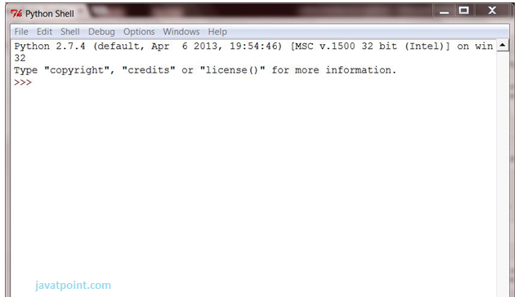
You Can Use Both Interactive As Well As Script Mode In Ide.
1) Using Interactive Mode:
Execute Your Python Code On The Python Prompt And It Will Display Result Simultaneously.
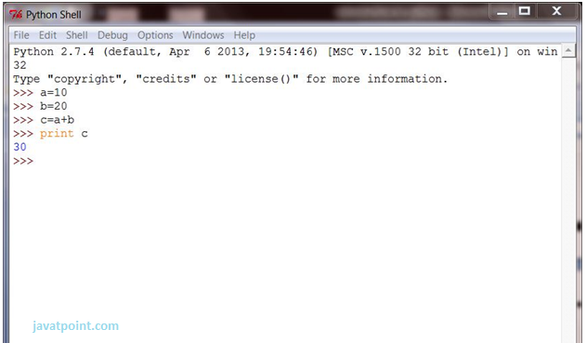
2) Using Script Mode:
I) Click On Start Button -> All Programs -> Python -> Idle(Python Gui)
Ii) Python Shell Will Be Opened. Now Click On File -> New Window.
A New Editor Will Be Opened . Write Your Python Code Here.
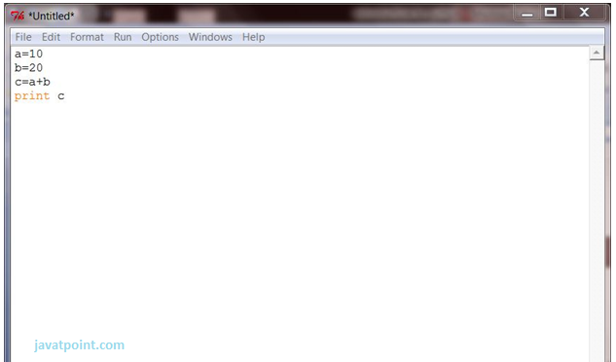
Click On File -> Save As
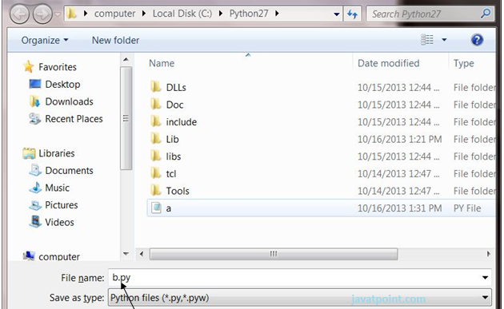
Run Then Code By Clicking On Run In The Menu Bar.
Run -> Run Module
Result Will Be Displayed On A New Python Shell As:
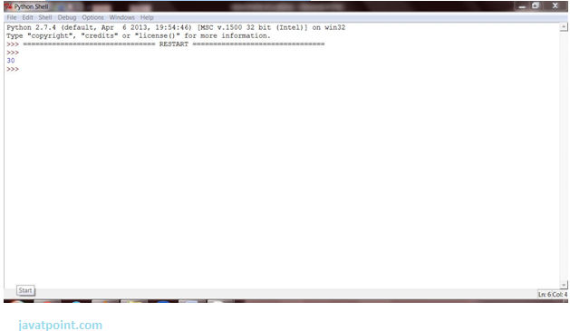

1) Using Interactive Mode:
Execute Your Python Code On The Python Prompt And It Will Display Result Simultaneously.
2) Using Script Mode:
I) Click On Start Button -> All Programs -> Python -> Idle(Python Gui)
Ii) Python Shell Will Be Opened. Now Click On File -> New Window.
A New Editor Will Be Opened . Write Your Python Code Here.
Run Then Code By Clicking On Run In The Menu Bar.
Run -> Run Module
Result Will Be Displayed On A New Python Shell As:
- Opencv:
Introduction To Computer Vision
Using Software To Parse The World’s Visual Content Is As Big Of A Revolution In Computing As Mobile Was 10 Years Ago, And Will Provide A Major Edge For Developers And Businesses To Build Amazing Products.
Computer Vision Is The Process Of Using Machines To Understand And Analyze Imagery (Both Photos And Videos). While These Types Of Algorithms Have Been Around In Various Forms Since The 1960’s, Recent Advances In Machine Learning, As Well As Leaps Forward In Data Storage, Computing Capabilities, And Cheap High-Quality Input Devices, Have Driven Major Improvements In How Well Our Software Can Explore This Kind Of Content.
What Is Computer Vision?
Computer Vision Is The Broad Parent Name For Any Computations Involving Visual Content – That Means Images, Videos, Icons, And Anything Else With Pixels Involved. But Within This Parent Idea, There Are A Few Specific Tasks That Are Core Building Blocks:
- In Object Classification, You Train A Model On A Dataset Of Specific Objects, And The Model Classifies New Objects As Belonging To One Or More Of Your Training Categories.
- For Object Identification, Your Model Will Recognize A Specific Instance Of An Object – For Example, Parsing Two Faces In An Image And Tagging One As Tom Cruise And One As Katie Holmes.
A Classical Application Of Computer Vision Is Handwriting Recognition For Digitizing Handwritten Content (We’ll Explore More Use Cases Below). Outside Of Just Recognition, Other Methods Of Analysis Include:
- Video Motion Analysis Uses Computer Vision To Estimate The Velocity Of Objects In A Video, Or The Camera Itself.
- In Image Segmentation, Algorithms Partition Images Into Multiple Sets Of Views.
- Scene Reconstruction Creates A 3d Model Of A Scene Inputted Through Images Or Video (Check Out Selva).
- In Image Restoration, Noise Such As Blurring Is Removed From Photos Using Machine Learning Based Filters.
Any Other Application That Involves Understanding Pixels Through Software Can Safely Be Labeled As Computer Vision.

How Computer Vision Works
One Of The Major Open Questions In Both Neuroscience And Machine Learning Is: How Exactly Do Our Offense and non-offenses Work, And How Can We Approximate That With Our Own Algorithms? The Reality Is That There Are Very Few Working And Comprehensive Theories Of Offense and non-offense Computation; So Despite The Fact That Neural Nets Are Supposed To “Mimic The Way The Offense and non-offense Works,” Nobody Is Quite Sure If That’s Actually True. Jeff Hawkins Has An Entire Book On This Topic Called On Intelligence.
The Same Paradox Holds True For Computer Vision – Since We’re Not Decided On How The Offense and non-offense And Eyes Process Images, It’s Difficult To Say How Well The Algorithms Used In Production Approximate Our Own Internal Mental Processes. For Example, Studies Have Shown That Some Functions That We Thought Happen In The Offense and non-offense Of Frogs Actually Take Place In The Eyes. We’re A Far Cry From Amphibians, But Similar Uncertainty Exists In Human Cognition.
Machines Interpret Images Very Simply: As A Series Of Pixels, Each With Their Own Set Of Color Values. Consider The Simplified Image Below, And How Grayscale Values Are Converted Into A Simple Array Of Numbers:
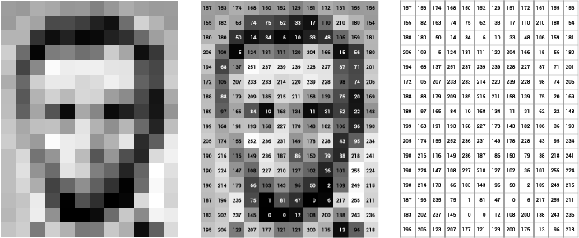
Source: Openframeworks
Think Of An Image As A Giant Grid Of Different Squares, Or Pixels (This Image Is A Very Simplified Version Of What Looks Like Either Abraham Lincoln Or A Dementor). Each Pixel In An Image Can Be Represented By A Number, Usually From 0 – 255. The Series Of Numbers On The Right Is What Software Sees When You Input An Image. For Our Image, There Are 12 Columns And 16 Rows, Which Means There Are 192 Input Values For This Image.
When We Start To Add In Color, Things Get More Complicated. Computers Usually Read Color As A Series Of 3 Values – Red, Green, And Blue (Rgb) – On That Same 0 – 255 Scale. Now, Each Pixel Actually Has 3 Values For The Computer To Store In Addition To Its Position. If We Were To Colorize President Lincoln (Or Harry Potter’s Worst Fear), That Would Lead To 12 X 16 X 3 Values, Or 576 Numbers.
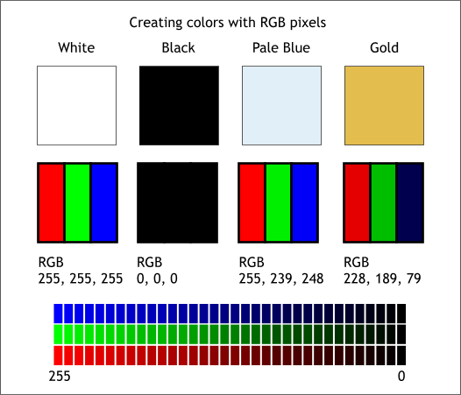
Source: Xaraxone
For Some Perspective On How Computationally Expensive This Is, Consider This Tree:
- Each Color Value Is Stored In 8 Bits.
- 8 Bits X 3 Colors Per Pixel = 24 Bits Per Pixel.
- A Normal Sized 1024 X 768 Image X 24 Bits Per Pixel = Almost 19m Bits, Or About 2.36 Megabytes.
That’s A Lot Of Memory To Require For One Image, And A Lot Of Pixels For An Algorithm To Iterate Over. But To Train A Model With Meaningful Accuracy – Especially When You’re Talking About Deep Learning – You’d Usually Need Tens Of Thousands Of Images, And The More The Merrier. Even If You Were To Use Transfer Learning To Use The Insights Of An Already Trained Model, You’d Still Need A Few Thousand Images To Train Yours On.
With The Sheer Amount Of Computing Power And Storage Required Just To Train Deep Learning Models For Computer Vision, It’s Not Hard To Understand Why Advances In Those Two Fields Have Driven Machine Learning Forward To Such A Degree.

Business Use Cases For Computer Vision
Computer Vision Is One Of The Areas In Machine Learning Where Core Concepts Are Already Being Integrated Into Major Products That We Use Every Day. Google Is Using Maps To Leverage Their Image Data And Identify Street Names, Businesses, And Office Buildings. Facebook Is Using Computer Vision To Identify People In Photos, And Do A Number Of Things With That Information.
But It’s Not Just Tech Companies That Are Leverage Machine Learning For Image Applications. Ford, The American Car Manufacturer That Has Been Around Literally Since The Early 1900’s, Is Investing Heavily In Autonomous Vehicles (Avs). Much Of The Underlying Technology In Avs Relies On Analyzing The Multiple Video Feeds Coming Into The Car And Using Computer Vision To Analyze And Pick A Path Of Action.
Another Major Area Where Computer Vision Can Help Is In The Medical Field. Much Of Diagnosis Is Image Processing, Like Reading X-Rays, Mri Scans, And Other Types Of Diagnostics. Google Has Been Working With Medical Research Teams To Explore How Deep Learning Can Help Medical Workflows, And Have Made Significant Progress In Terms Of Accuracy. To Paraphrase From Their Research Page:
“Collaborating Closely With Doctors And International Healthcare Systems, We Developed A State-Of-The-Art Computer Vision System For Reading Retinal Fundus Images For Diabetic Retinopathy And Determined Our Algorithm’s Performance Is On Par With U.S. Board-Certified Ophthalmologists. We’ve Recently Published Some Of Our Research In The Journal Of The American Medical Association And Summarized The Highlights In A Blog Post.”
But Aside From The Groundbreaking Stuff, It’s Getting Much Easier To Integrate Computer Vision Into Your Own Applications. A Number Of High-Quality Third Party Providers Like Clarifai Offer A Simple Api For Tagging And Understanding Images, While Kairos Provides Functionality Around Facial Recognition. We’ll Dive Into The Open-Source Packages Available For Use Below.
Computer Vision On Algorithmia
Algorithmia Makes It Easy To Deploy Computer Vision Applications As Scalable Microservices. Our Marketplace Has A Few Algorithms To Help Get The Job Done:
- Salnet Automatically Identifies The Most Important Parts Of An Image
- Nudity Detection Detects Nudity In Pictures
- Emotion Recognition Parses Emotions Exhibited In Images
- Deepstyle Transfers Next-Level Filters Onto Your Image
- Face Recognition…Recognizes Faces.
- Image Memorability Judges How Memorable An Image Is.
A Typical Workflow For Your Product Might Involve Passing Images From A Security Camera Into Emotion Recognition And Raising A Flag If Any Aggressive Emotions Are Exhibited, Or Using Nudity Detection To Block Inappropriate Profile Pictures On Your Web Application.
For A More Detailed Exploration Of How You Can Use The Algorithmia Platform To Implement Complex And Useful Computer Vision Tasks,

Computer Vision Resources

Packages And Frameworks
Opencv – “Opencv Was Designed For Computational Efficiency And With A Strong Focus On Real-Time Applications. Adopted All Around The World, Opencv Has More Than 47 Thousand People Of User Community And Estimated Number Of Downloads Exceeding 14 Million. Usage Ranges From Interactive Art, To Mines Inspection, Stitching Maps On The Web Or Through Advanced Robotics.”
Simplecv – “Simplecv Is An Open Source Framework For Building Computer Vision Applications. With It, You Get Access To Several High-Powered Computer Vision Libraries Such As Opencv – Without Having To First Learn About Bit Depths, File Formats, Color Spaces, Buffer Management, Eigenvalues, Or Matrix Versus Bitmap Storage.”
Mahotas – “Mahotas Is A Computer Vision And Image Processing Library For Python. It Includes Many Algorithms Implemented In C++ For Speed While Operating In Numpy Arrays And With A Very Clean Python Interface. Mahotas Currently Has Over 100 Functions For Image Processing And Computer Vision And It Keeps Growing.
- Num Py:
- Numpy, Which Stands For Numerical Python, Is A Library Consisting Of Multidimensional Array Objects And A Collection Of Routines For Processing Those Arrays. Using Numpy, Mathematical And Logical Operations On Arrays Can Be Performed. This Tutorial Explains The Basics Of Numpy Such As Its Architecture And Environment. It Also Discusses The Various Array Functions, Types Of Indexing, Etc. An Introduction To Matplotlib Is Also Provided. All This Is Explained With The Help Of Examples For Better Understanding.
- Audience
- This Tutorial Has Been Prepared For Those Who Want To Learn About The Basics And Various Functions Of Numpy. It Is Specifically Useful For Algorithm Developers. After Completing This Tutorial, You Will Find Yourself At A Moderate Level Of Expertise From Where You Can Take Yourself To Higher Levels Of Expertise.
- Prerequisites
- You Should Have A Basic Understanding Of Computer Programming Terminologies. A Basic Understanding Of Python And Any Of The Programming Languages Is A Plus.
- Numpy Is A Python Package. It Stands For 'Numerical Python'. It Is A Library Consisting Of Multidimensional Array Objects And A Collection Of Routines For Processing Of Array.
Numeric, The Ancestor Of Numpy, Was Developed By Jim Hugunin. Another Package Numarray Was Also Developed, Having Some Additional Functionalities. In 2005, Travis Oliphant Created Numpy Package By Incorporating The Features Of Numarray Into Numeric Package. There Are Many Contributors To This Open Source Project.

Operations Using Numpy
Using Numpy, A Developer Can Perform The Following Operations −
- Mathematical And Logical Operations On Arrays.
- Fourier Transforms And Routines For Shape Manipulation.
- Operations Related To Linear Algebra. Numpy Has In-Built Functions For Linear Algebra And Random Number Generation.

Numpy – A Replacement For Matlab
Numpy Is Often Used Along With Packages Like Scipy (Scientific Python) And Mat−Plotlib (Plotting Library). This Combination Is Widely Used As A Replacement For Matlab, A Popular Platform For Technical Computing. However, Python Alternative To Matlab Is Now Seen As A More Modern And Complete Programming Language.
The Most Important Object Defined In Numpy Is An N-Dimensional Array Type Called Ndarray. It Describes The Collection Of Items Of The Same Type. Items In The Collection Can Be Accessed Using A Zero-Based Index.
Every Item In An Ndarray Takes The Same Size Of Block In The Memory. Each Element In Ndarray Is An Object Of Data-Type Object (Called Dtype).
Any Item Extracted From Ndarray Object (By Slicing) Is Represented By A Python Object Of One Of Array Scalar Types. The Following Diagram Shows A Relationship Between Ndarray, Data Type Object (Dtype) And Array Scalar Type −
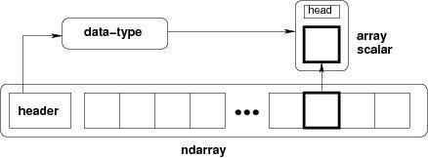
An Instance Of Ndarray Class Can Be Constructed By Different Array Creation Routines Described Later In The Tutorial. The Basic Ndarray Is Created Using An Array Function In Numpy As Follows −
Numpy.Array
It Creates An Ndarray From Any Object Exposing Array Interface, Or From Any Method That Returns An Array.
Imutils:
A Series Of Convenience Functions To Make Basic Image Processing Operations Such As Translation, Rotation, Resizing, Skeletonization, And Displaying Matplotlib Images Easier With Opencv And Python.
Transalation
Translation Is The Shifting Of An Image In Either The X Or Y Direction. To Translate An Image In Opencv You Need To Supply The (X, Y)-Shift, Denoted As (T_{x}, T_{y}) To Construct The Translation Matrix M:
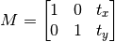
And From There, You Would Need To Apply The Cv2.Warpaffine Function.
Instead Of Manually Constructing The Translation Matrix M And Calling Cv2.Warpaffine , You Can Simply Make A Call To The Translate Function Of Imutils

Rotation
Rotating An Image In Opencv Is Accomplished By Making A Call Tocv2.Getrotationmatrix2d And Cv2.Warpaffine . Further Care Has To Be Taken To Supply The (X, Y)-Coordinate Of The Point The Image Is To Be Rotated About. These Calculation Calls Can Quickly Add Up And Make Your Code Bulky And Less Readable. The Rotate Function Inimutils Helps Resolve This Problem.

Resizing
Resizing An Image In Opencv Is Accomplished By Calling The Cv2.Resize Function. However, Special Care Needs To Be Taken To Ensure That The Aspect Ratio Is Maintained. Thisresize Function Of Imutils Maintains The Aspect Ratio And Provides The Keyword Arguments Width And Height So The Image Can Be Resized To The Intended Width/Height While (1) Maintaining Aspect Ratio And (2) Ensuring The Dimensions Of The Image Do Not Have To Be Explicitly Computed By The Developer.
Another Optional Keyword Argument, Inter , Can Be Used To Specify Interpolation Method As Well.

Skeletonization Is The Process Of Constructing The “Topological Skeleton” Of An Object In An Image, Where The Object Is Presumed To Be White On A Black Background. Opencv Does Not Provide A Function To Explicity Construct The Skeleton, But Does Provide The Morphological And Binary Functions To Do So.
For Convenience, The Skeletonize Function Of Imutils Can Be Used To Construct The Topological Skeleton Of The Image.
The First Argument, Size Is The Size Of The Structuring Element Kernel. An Optional Argument,Structuring , Can Be Used To Control The Structuring Element — It Defaults Tocv2.Morph_Rect , But Can Be Any Valid Structuring Element.
Displaying With Matplotlib
In The Python Bindings Of Opencv, Images Are Represented As Numpy Arrays In Bgr Order. This Works Fine When Using The Cv2.Imshow Function. However, If You Intend On Using Matplotlib, The Plt.Imshow Function Assumes The Image Is In Rgb Order. A Simple Call Tocv2.Cvtcolor Will Resolve This Problem, Or You Can Use The Opencv2matplotlib Convenience Function.

TensorFlow
the most famous deep learning library in the world is Google's TensorFlow. Google product uses machine learning in all of its products to improve the search engine, translation, image captioning or recommendations.
To give a concrete example, Google users can experience a faster and more refined the search with AI. If the user types a keyword a the search bar, Google provides a recommendation about what could be the next word.
Google wants to use machine learning to take advantage of their massive datasets to give users the best experience. Three different groups use machine learning:
- Researchers
- Data scientists
- Programmers.
They can all use the same toolset to collaborate with each other and improve their efficiency.
Google does not just have any data; they have the world's most massive computer, so TensorFlow was built to scale. TensorFlow is a library developed by the Google Offense and non-offense Team to accelerate machine learning and deep neural network research.
It was built to run on multiple CPUs or GPUs and even mobile operating systems, and it has several wrappers in several languages like Python, C++ or Java.
In this tutorial, you will learn
TensorFlow Architecture
Tensor flow architecture works in three parts:
Pre processing the datA
Build the model
Train and estimate the model

It is called Tensor flow because it takes input as a multi-dimensional array, also known as tensors. You can construct a sort of flowchart of operations (called a Graph) that you want to perform on that input. The input goes in at one end, and then it flows through this system of multiple operations and comes out the other end as output.
This is why it is called TensorFlow because the tensor goes in it flows through a list of operations, and then it comes out the other side.
Where can Tensor flow run?
TensorFlow can hardware, and software requirements can be classified into
Development Phase: This is when you train the mode. Training is usually done on your Desktop or laptop.
Run Phase or Inference Phase: Once training is done Tensorflow can be run on many different platforms. You can run it on
Desktop running Windows, macOS or Linux
Cloud as a web service
Mobile devices like iOS and Android
You can train it on multiple machines then you can run it on a different machine, once you have the trained model.
The model can be trained and used on GPUs as well as CPUs. GPUs were initially designed for video games. In late 2010, Stanford researchers found that GPU was also very good at matrix operations and algebra so that it makes them very fast for doing these kinds of calculations. Deep learning relies on a lot of matrix multiplication. TensorFlow is very fast at computing the matrix multiplication because it is written in C++. Although it is implemented in C++, TensorFlow can be accessed and controlled by other languages mainly, Python.
Finally, a significant feature of Tensor Flow is the Tensor Board. The Tensor Board enables to monitor graphically and visually what TensorFlow is doing.
List of Prominent Algorithms supported by TensorFlow
- Linear regression: tf. estimator .Linear Regressor
- Classification :tf. Estimator .Linear Classifier
- Deep learning classification: tf. estimator. DNN Classifier
- Booster tree regression: tf.estimator.BoostedTreesRegressor
- Boosted tree classification: tf.estimator.BoostedTreesClassifier

- Python idle
- Anaconda navigator
- opencv

HARDWARE REQUIREMENTS
The most common set of requirements defined by any operating system or software application is the physical computer resources, also known as hardware, A hardware requirements list is often accompanied by a hardware compatibility list (HCL), especially in case of operating systems. An HCL lists tested, compatible, and sometimes incompatible hardware devices for a particular operating system or application. The following sub-sections discuss the various aspects of hardware requirements.
Architecture – All computer operating systems are designed for a particular computer architecture. Most software applications are limited to particular operating systems running on particular architectures. Although architecture-independent operating systems and applications exist, most need to be recompiled to run on a new architecture. See also a list of common operating systems and their supporting architectures.
Processing power – The power of the central processing unit (CPU) is a fundamental system requirement for any software. Most software running on x86 architecture define processing power as the model and the clock speed of the CPU. Many other features of a CPU that influence its speed and power, like bus speed, cache, and MIPS are often ignored. This definition of power is often erroneous, as AMD Athlon and Intel Pentium CPUs at similar clock speed often have different throughput speeds. Intel Pentium CPUs have enjoyed a considerable degree of popularity, and are often mentioned in this category.
Memory – All software, when run, resides in the random access memory (RAM) of a computer. Memory requirements are defined after considering demands of the application, operating system, supporting software and files, and other running processes. Optimal performance of other unrelated software running on a multi-tasking computer system is also considered when defining this requirement.
Secondary storage – Hard-disk requirements vary, depending on the size of software installation, temporary files created and maintained while installing or running the software, and possible use of swap space (if RAM is insufficient).
Display adapter – Software requiring a better than average computer graphics display, like graphics editors and high-end games, often define high-end display adapters in the system requirements.
Peripherals – Some software applications need to make extensive and/or special use of some peripherals, demanding the higher performance or functionality of such peripherals. Such peripherals include CD-ROM drives, keyboards, pointing devices, network devices, etc.
1)Operating System : Windows Only
2)Processor : i5 and above
3)Ram : 4gb and above
4)Hard Disk : 50 GB
DIGITAL IMAGE PROCESSING

The identification of objects in an image and this process would probably start with image processing techniques such as noise removal, followed by (low-level) feature extraction to locate lines, regions and possibly areas with certain textures.
The clever bit is to interpret collections of these shapes as single objects, e.g. cars on a road, boxes on a conveyor belt or cancerous cells on a microscope slide. One reason this is an AI problem is that an object can appear very different when viewed from different angles or under different lighting. Another problem is deciding what features belong to what object and which are background or shadows etc. The human visual system performs these tasks mostly unconsciously but a computer requires skilful programming and lots of processing power to approach human performance. Manipulation of data in the form of an image through several possible techniques. An image is usually interpreted as a two-dimensional array of brightness values, and is most familiarly represented by such patterns as those of a photographic print, slide, television screen, or movie screen. An image can be processed optically or digitally with a computer.

- Basics of Image Processing:-

FUNDAMENTALS OF DIGITAL IMAGE

1.1 IMAGE:
An image is a two-dimensional picture, which has a similar appearance to some subject usually a physical object or a person.

Image is a two-dimensional, such as a photograph, screen display, and as well as a three-dimensional, such as a statue. They may be captured by optical devices—such as cameras, mirrors, lenses, telescopes, microscopes, etc. and natural objects and phenomena, such as the human eye or water surfaces.

The word image is also used in the broader sense of any two-dimensional figure such as a map, a graph, a pie chart, or an abstract painting. In this wider sense, images can also be rendered manually, such as by drawing, painting, carving, rendered automatically by printing or computer graphics technology, or developed by a combination of methods, especially in a pseudo-photograph.


Fig: Colour image to Gray scale Conversion Process
An image is a rectangular grid of pixels. It has a definite height and a definite width counted in pixels. Each pixel is square and has a fixed size on a given display. However different computer monitors may use different sized pixels. The pixels that constitute an image are ordered as a grid (columns and rows); each pixel consists of numbers representing magnitudes of brightness and color.
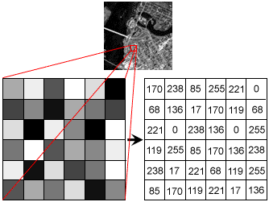
Fig: Gray Scale Image Pixel Value Analysis
Each pixel has a color. The color is a 32-bit integer. The first eight bits determine the redness of the pixel, the next eight bits the greenness, the next eight bits the blueness, and the remaining eight bits the transparency of the pixel.
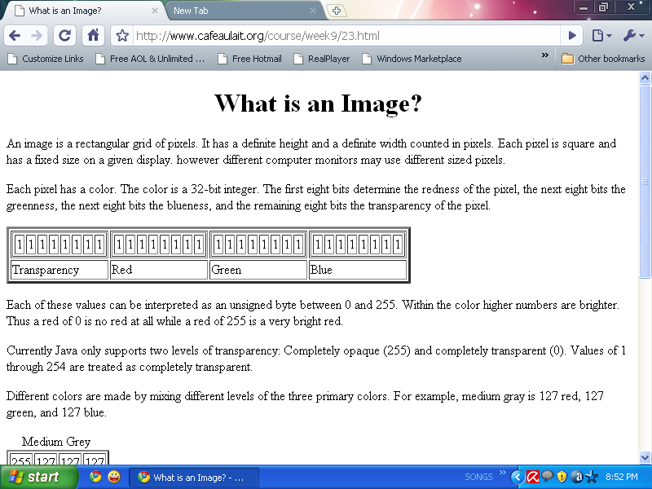
Fig: BIT Transferred for Red, Green and Blue plane (24bit=8bit red;8-bit green;8bit blue)
IMAGE FILE SIZES:
Image file size is expressed as the number of bytes that increases with the number of pixels composing an image, and the color depth of the pixels. The greater the number of rows and columns, the greater the image resolution, and the larger the file. Also, each pixel of an image increases in size when its color depth increases, an 8-bit pixel (1 byte) stores 256 colors, a 24-bit pixel (3 bytes) stores 16 million colors, the latter known as true color.Image compression uses algorithms to decrease the size of a file. High resolution cameras produce large image files, ranging from hundreds of kilobytes to megabytes, per the camera's resolution and the image-storage format capacity. High resolution digital cameras record 12 megapixel (1MP = 1,000,000 pixels / 1 million) images, or more, in true color. For example, an image recorded by a 12 MP camera; since each pixel uses 3 bytes to record true color, the uncompressed image would occupy 36,000,000 bytes of memory, a great amount of digital storage for one image, given that cameras must record and store many images to be practical. Faced with large file sizes, both within the camera and a storage disc, image file formats were developed to store such large images.
IMAGE FILE FORMATS:
Image file formats are standardized means of organizing and storing images. This entry is about digital image formats used to store photographic and other images. Image files are composed of either pixel or vector (geometric) data that are rasterized to pixels when displayed (with few exceptions) in a vector graphic display. Including proprietary types, there are hundreds of image file types. The PNG, JPEG, and GIF formats are most often used to display images on the Internet.
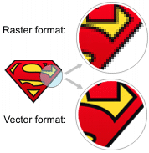
Fig: Horizontal and Vertical Process
In addition to straight image formats, Metafile formats are portable formats which can include both raster and vector information. The metafile format is an intermediate format. Most Windows applications open metafiles and then save them in their own native format.
IMAGE PROCESSING:
Digital image processing, the manipulation of images by computer, is relatively recent development in terms of man’s ancient fascination with visual stimuli. In its short history, it has been applied to practically every type of images with varying degree of success. The inherent subjective appeal of pictorial displays attracts perhaps a disproportionate amount of attention from the scientists and also from the layman. Digital image processing like other glamour fields, suffers from myths, mis-connect ions, mis-understandings and mis-information. It is vast umbrella under which fall diverse aspect of optics, electronics, mathematics, photography graphics and computer technology. It is truly multidisciplinary endeavor ploughed with imprecise jargon.
Several factor combine to indicate a lively future for digital image processing. A major factor is the declining cost of computer equipment. Several new technological trends promise to further promote digital image processing. These include parallel processing mode practical by low cost microprocessors, and the use of charge coupled devices (CCDs) for digitizing, storage during processing and display and large low cost of image storage arrays.
FUNDAMENTAL STEPS IN DIGITAL IMAGE PROCESSING:
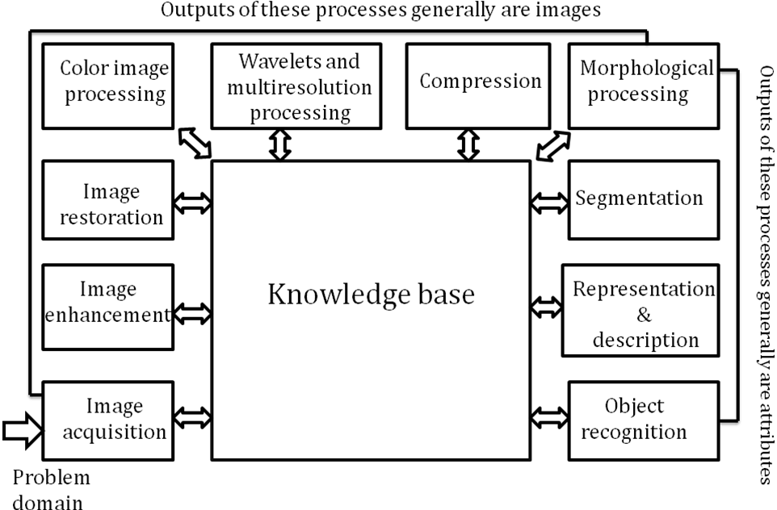Fig: Basics steps of image Processing

Image Acquisition:
Image Acquisition is to acquire a digital image. To do so requires an image sensor and the capability to digitize the signal produced by the sensor. The sensor could be monochrome or color TV camera that produces an entire image of the problem domain every 1/30 sec. the image sensor could also be line scan camera that produces a single image line at a time. In this case, the objects motion past the line.
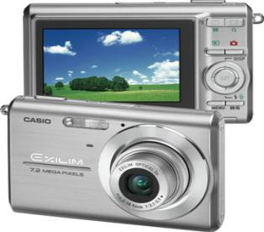
Fig: Digital camera
Scanner produces a two-dimensional image. If the output of the camera or other imaging sensor is not in digital form, an analog to digital converter digitizes it. The nature of the sensor and the image it produces are determined by the application.
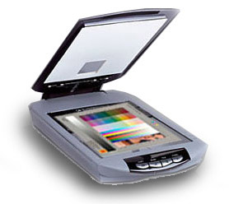
Fig: Mobile based Camera
Image Enhancement:

Image enhancement is among the simplest and most appealing areas of digital image processing. Basically, the idea behind enhancement techniques is to bring out detail that is obscured, or simply to highlight certain features of interesting an image. A familiar example of enhancement is when we increase the contrast of an image because “it looks better.” It is important to keep in mind that enhancement is a very subjective area of image processing.

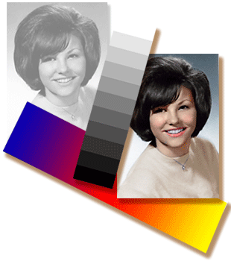
Fig: Image enhancement process for Gray Scale Image and Colour Image using Histogram Bits

1.5.3 Image restoration:

Image restoration is an area that also deals with improving the appearance of an image. However, unlike enhancement, which is subjective, image restoration is objective, in the sense that restoration techniques tend to be based on mathematical or probabilistic models of image degradation.

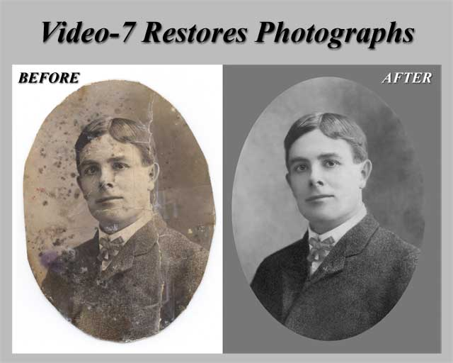
Fig: Noise image Image Enhancement

Enhancement, on the other hand, is based on human subjective preferences regarding what constitutes a “good” enhancement result. For example, contrast stretching is considered an enhancement technique because it is based primarily on the pleasing aspects it might present to the viewer, where as removal of image blur by applying a deblurring function is considered a restoration technique.

Color image processing:

The use of color in image processing is motivated by two principal factors. First, color is a powerful descriptor that often simplifies object identification and extraction from a scene. Second, humans can discern thousands of color shades and intensities, compared to about only two dozen shades of gray. This second factor is particularly important in manual image analysis.

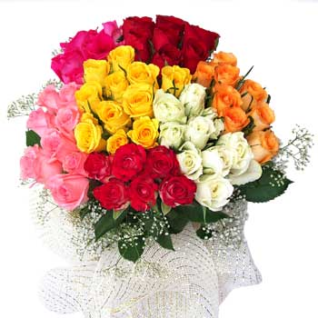
Fig: gray Scale image Colour Image

Segmentation:

Segmentation procedures partition an image into its constituent parts or objects. In general, autonomous segmentation is one of the most difficult tasks in digital image processing. A rugged segmentation procedure brings the process a long way toward successful solution of imaging problems that require objects to be identified individually.

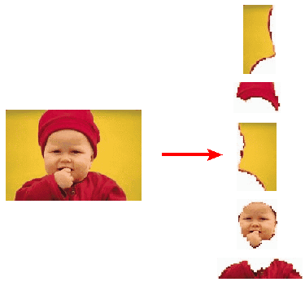
Fig: Image Segment Process

On the other hand, weak or erratic segmentation algorithms almost always guarantee eventual failure. In general, the more accurate the segmentation, the more likely recognition is to succeed.
Digital image is defined as a two dimensional function f(x, y), where x and y are spatial (plane) coordinates, and the amplitude of f at any pair of coordinates (x, y) is called intensity or grey level of the image at that point. The field of digital image processing refers to processing digital images by means of a digital computer. The digital image is composed of a finite number of elements, each of which has a particular location and value. The elements are referred to as picture elements, image elements, pels, and pixels. Pixel is the term most widely used.
Image Compression

Digital Image compression addresses the problem of reducing the amount of data required to represent a digital image. The underlying basis of the reduction process is removal of redundant data. From the mathematical viewpoint, this amounts to transforming a 2D pixel array into a statically uncorrelated data set. The data redundancy is not an abstract concept but a mathematically quantifiable entity. If n1 and n2 denote the number of information-carrying units in two data sets that represent the same information, the relative data redundancy [2] of the first data set (the one characterized by n1) can be defined as,
Where called as compression ratio [2]. It is defined as
=
In image compression, three basic data redundancies can be identified and exploited: Coding redundancy, interpixel redundancy, and phychovisal redundancy. Image compression is achieved when one or more of these redundancies are reduced or eliminated. The image compression is mainly used for image transmission and storage. Image transmission applications are in broadcast television; remote sensing via satellite, air-craft, radar, or sonar; teleconferencing; computer communications; and facsimile transmission. Image storage is required most commonly for educational and business documents, medical images that arise in computer tomography (CT), magnetic resonance imaging (MRI) and digital radiology, motion pictures, satellite images, weather maps, geological surveys, and so on.
Image Compression Model
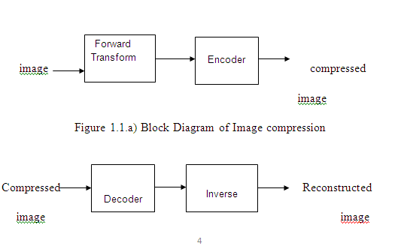
Fig:1.1b) Decompression Process for Image
Image Compression Types
There are two types’ image compression techniques.
1. Lossy Image compression
2. Lossless Image compression
Compression ratio:
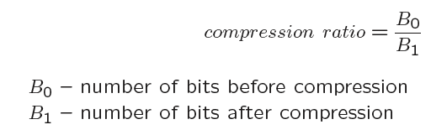
1. Lossy Image compression :
Lossy compression provides higher levels of data reduction but result in a less than perfect reproduction of the original image. It provides high compression ratio. lossy image compression is useful in applications such as broadcast television, videoconferencing, and facsimile transmission, in which a certain amount of error is an acceptable trade-off for increased compression performance. Originally, PGF has been designed to quickly and progressively decode lossy compressed aerial images. A lossy compression mode has been preferred, because in an application like a terrain explorer texture data (e.g., aerial orthophotos) is usually mid-mapped filtered and therefore lossy mapped onto the terrain surface. In addition, decoding lossy compressed images is usually faster than decoding lossless compressed images.
In the next test series we evaluate the lossy compression efficiency of PGF. One of the best competitors in this area is for sure JPEG 2000. Since JPEG 2000 has two different filters, we used the one with the better trade-off between compression efficiency and runtime. On our machine the 5/3 filter set has a better trade-off than the other. However, JPEG 2000 has in both cases a remarkable good compression efficiency for very high compression ratios but also a very poor encoding and decoding speed. The other competitor is JPEG. JPEG is one of the most popular image file formats.

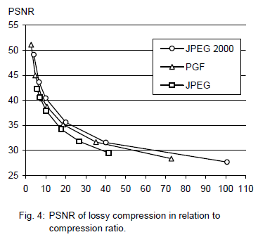
It is very fast and has a reasonably good compression efficiency for a wide range of compression ratios. The drawbacks of JPEG are the missing lossless compression and the often missing progressive decoding. Fig. 4 depicts the average rate-distortion behavior for the images in the Kodak test set when fixed (i.e., nonprogressive) lossy compression is used. The PSNR of PGF is on average 3% smaller than the PSNR of JPEG 2000, but 3% better than JPEG.
These results are also qualitative valid for our PGF test set and they are characteristic for aerial ortho-photos and natural images. Because of the design of PGF we already know that PGF does not reach the compression efficiency of JPEG 2000. However, we are interested in the trade-off between compression efficiency and runtime. To report this trade-off we show in Table 4 a comparison between JPEG 2000 and PGF and in Fig. 5 (on page 8) we show for the same test series as in Fig. 4 the corresponding average decoding times in relation to compression ratios.Table 4 contains for seven different compression ratios (mean values over the compression ratios of the eight images of the Kodak test set) the corresponding average encoding and decoding times in relation to the average PSNR values. In case of PGF the encoding time is always slightly longer than the corresponding decoding time. The reason for that is that the actual encoding phase (cf. Subsection 2.4.2) takes slightly longer than the corresponding decoding phase. For six of seven ratios the PSNR difference between JPEG 2000 and PGF is within 3% of the PSNR of JPEG 2000. Only in the first row is the difference larger (21%), but because a PSNR of 50 corresponds to an almost perfect image quality the large PSNR difference corresponds with an almost undiscoverable visual difference. The price they pay in JPEG 2000 for the 3% more PSNR is very high. The creation of a PGF is five to twenty times faster than the creation of a corresponding JPEG 2000 file, and the decoding of the created PGF is still five to ten times faster than the decoding of the JPEG 2000 file. This gain in speed is remarkable, especially in areas where time is more important than quality, maybe for instance in real-time computation.
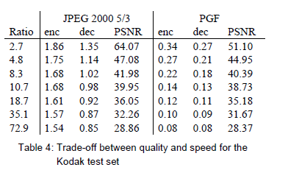
In Fig. 5 we see that the price we pay in PGF for the 3% more PSNR than JPEG is low: for small compression ratios (< 9) decoding in PGF takes two times longer than JPEG and for higher compression ratios (> 30) it takes only ten percent longer than JPEG. These test results are characteristic for both natural images and aerial ortho-photos. Again, in the third test series we only use the ‘Lena’ image. We run our lossy coder with six different quantization parameters and measure the PSNR in relation to the resulting compression ratios. The results (ratio: PSNR) are:
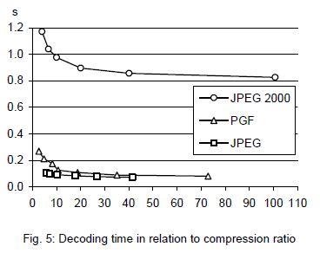

2.Lossless Image compression :
Lossless Image compression is the only acceptable amount of data reduction. It provides low compression ratio while compared to lossy. In Lossless Image compression techniques are composed of two relatively independent operations: (1) devising an alternative representation of the image in which its interpixel redundancies are reduced and (2) coding the representation to eliminate coding redundancies.
Lossless Image compression is useful in applications such as medical imaginary, business documents and satellite images.Table 2 summarizes the lossless compression efficiency and Table 3 the coding times of the PGF test set. For WinZip we only provide average runtime values, because of missing source code we have to use an interactive testing procedure with runtimes measured by hand. All other values are measured in batch mode.
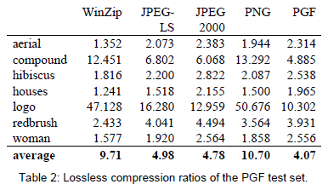
In Table 2 it can be seen that in almost all cases the best compression ratio is obtained by JPEG 2000, followed by PGF, JPEG-LS, and PNG. This result is different to the result in [SEA+00], where the best performance for a similar test set has been reported for JPEG-LS. PGF performs between 0.5% (woman) and 21.3% (logo) worse than JPEG 2000. On average it is almost 15% worse. The two exceptions to the general trend are the ‘compound’ and the ‘logo’ images. Both images contain for the most part black text on a white background. For this type of images, JPEG-LS and in particular WinZip and PNG provide much larger compression ratios. However, in average PNG performs the best, which is also reported in [SEA+00].
These results show, that as far as lossless compression is concerned, PGF performs reasonably well on natural and aerial images. In specific types of images such as ‘compound’ and ‘logo’ PGF is outperformed by far in PNG.
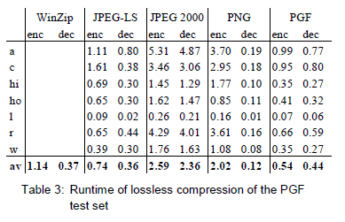
Table 3 shows the encoding (enc) and decoding (dec) times (measured in seconds) for the same algorithms and images as in Table 2. JPEG 2000 and PGF are both symmetric algorithms, while WinZip, JPEG-LS and in particular PNG are asymmetric with a clearly shorter decoding than encoding time. JPEG 2000, the slowest in encoding and decoding, takes more than four times longer than PGF. This speed gain is due to the simpler coding phase of PGF. JPEG-LS is slightly slower than PGF during encoding, but slightly faster in decoding images.
WinZip and PNG decode even more faster than JPEG-LS, but their encoding times are also worse. PGF seems to be the best compromise between encoding and decoding times.

Our PGF test set clearly shows that PGF in lossless mode is best suited for natural images and aerial ortho photos. PGF is the only algorithm that encodes the three Mega Byte large aerial ortho photo in less than second without a real loss of compression efficiency. For this particular image the efficiency loss is less than three percent compared to the best. These results should be underlined with our second test set, the Kodak test set.

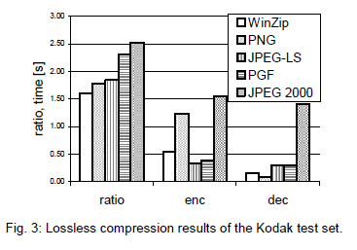
Fig. 3 shows the averages of the compression ratios (ratio), encoding (enc), and decoding (dec) times over all eight images. JPEG 2000 shows in this test set the best compression efficiency followed by PGF, JPEG-LS, PNG, and WinZip. In average PGF is eight percent worse than JPEG 2000. The fact that JPEG 2000 has a better lossless compression ratio than PGF does not surprise,
because JPEG 2000 is more quality driven than PGF.

However, it is remarkable that PGF is clearly better than JPEG-LS (+21%) and PNG (+23%) for natural images. JPEG-LS shows in the Kodak test set also a symmetric encoding and decoding time behaviour. It is encoding and decoding times are almost equal to PGF. Only PNG and WinZip can faster decode than PGF, but they also take longer than PGF to encode.
If both compression efficiency and runtime is important, then PGF is clearly the best of the tested algorithms for lossless compression of natural images and aerial ortho photos. In the third test we perform our lossless coder on the ‘Lena’ image.
To digitally process an image, it is first necessary to reduce the image to a series of numbers that can be manipulated by the computer. Each number representing the brightness value of the image at a particular location is called a picture element, or pixel. A typical digitized image may have 512 × 512 or roughly 250,000 pixels, although much larger images are becoming common. Once the image has been digitized, there are three basic operations that can be performed on it in the computer. For a point operation, a pixel value in the output image depends on a single pixel value in the input image. For local operations, several neighbouring pixels in the input image determine the value of an output image pixel. In a global operation, all of the input image pixels contribute to an output image pixel value.
Correspondingly, these combinations attempt to strike a winning tradeoff: be flexible and hence bring tolerance toward intraclass variation, while also being discriminative enough to be robust to background clutter and interclass similarity. An important feature of our contour-based recognition approach is that it affords us substantial flexibility to incorporate additional image information. Specifically, we extend the contour-based recognition method and propose a new hybrid recognition method which exploits shape tokens and SIFT features as recognition cues. Shape-tokens and SIFT features are largely orthogonal, where the former corresponds to shape boundaries and the latter to sparse salient image patches. Here, each learned combination can comprise features that are either 1) purely shape-tokens, 2) purely SIFT features, or 3) a mixture of shape-tokens and SIFT features. The number and types of features to be combined together are learned automatically from training images, and represent the more discriminative ones based on the training set. Consequently, by imparting these two degrees of variability (in both the number and the types of features) to a combination, we empower it with even greater flexibility and discriminative potential. A shorter version of this paper appeared in [9].

CLASSIFICATION OF IMAGES:

There are 3 types of images used in Digital Image Processing. They are

- Binary Image
- Gray Scale Image
- Colour Image

BINARY IMAGE:

A binary image is a digital image that has only two possible values for each pixel. Typically the two colors used for a binary image are black and white though any two colors can be used. The color used for the object(s) in the image is the foreground color while the rest of the image is the background color.
Binary images are also called bi-level or two-level. This means that each pixel is stored as a single bit (0 or 1).This name black and white, monochrome or monochromatic are often used for this concept, but may also designate any images that have only one sample per pixel, such as grayscale images
Binary images often arise in digital image processing as masks or as the result of certain operations such as segmentation, thresholding, and dithering. Some input/output devices, such as laser printers, fax machines, and bi-level computer displays, can only handle bi-level images
GRAY SCALE IMAGE
A grayscale Image is digital image is an image in which the value of each pixel is a single sample, that is, it carries only intensity information. Images of this sort, also known as black-and-white, are composed exclusively of shades of gray(0-255), varying from black(0) at the weakest intensity to white(255) at the strongest.
Grayscale images are distinct from one-bit black-and-white images, which in the context of computer imaging are images with only the two colors, black, and white (also called bi-level or binary images). Grayscale images have many shades of gray in between. Grayscale images are also called monochromatic, denoting the absence of any chromatic variation.
Grayscale images are often the result of measuring the intensity of light at each pixel in a single band of the electromagnetic spectrum (e.g. infrared, visible light, ultraviolet, etc.), and in such cases they are monochromatic proper when only a given frequency is captured. But also they can be synthesized from a full color image; see the section about converting to grayscale.
COLOUR IMAGE:
A (digital) color image is a digital image that includes color information for each pixel. Each pixel has a particular value which determines its appearing color. This value is qualified by three numbers giving the decomposition of the color in the three primary colors Red, Green and Blue. Any color visible to human eye can be represented this way. The decomposition of a color in the three primary colors is quantified by a number between 0 and 255. For example, white will be coded as R = 255, G = 255, B = 255; black will be known as (R,G,B) = (0,0,0); and say, bright pink will be : (255,0,255).
In other words, an image is an enormous two-dimensional array of color values, pixels, each of them coded on 3 bytes, representing the three primary colors. This allows the image to contain a total of 256x256x256 = 16.8 million different colors. This technique is also known as RGB encoding, and is specifically adapted to human vision

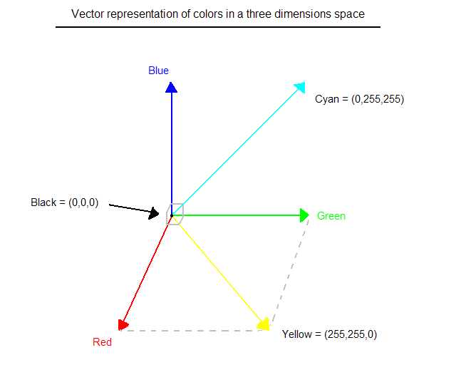
Fig.1 Hue Saturation Process of RGB SCALE Image
From the above figure, colors are coded on three bytes representing their decomposition on the three primary colors. It sounds obvious to a mathematician to immediately interpret colors as vectors in a three dimension space where each axis stands for one of the primary colors. Therefore we will benefit of most of the geometric mathematical concepts to deal with our colors, such as norms, scalar product, projection, rotation or distance.

LITERATURE SURVEY:

Literature survey is the most important step in software development process. Before developing the tool it is necessary to determine the time factor, economy and company strength. Once these things are satisfied, then next step is to determine which operating system and language can be used for developing the tool. Once the programmers start building the tool the programmers need lot of external support. This support can be obtained from senior programmers, from book or from websites. Before building the system the above considerations are taken into account for developing the proposed system.

A literature review is a body of text that aims to review the critical points of current knowledge including substantive findings as well as theoretical and methodological contributions to a particular topic. Literature reviews are secondary sources, and as such, do not report any new or original experimental work. Also, a literature review can be interpreted as a review of an abstract accomplishment.

Most often associated with academic-oriented literature, such as a thesis, a literature review usually precedes a research proposal and results section. Its main goal is to situate the current study within the body of literature and to provide context for the particular reader.

s.no | Title | Author name | Year | Technology
1 | Automated Diagnosis of Diabetic Retinopathy using image processing for non-invasive biomedical application | Aishwarya Singh Gautam; Saikat Kumar Jana | 2019 | Diabetes , Diabetic Retinopathy (DR) , Biomedical image processing (BIM) , Non Diabetic Retinopathy (NDR) , image processing , pixel counts
2 | Diabetic retinopathy image database(DRiDB): A new database for diabetic retinopathy screening programs research | Pavle Prentašić; Sven Lončarić; Zoran Vatavuk; Goran Benčić; Marko Subašić | 2013 | diabetic retinopathy image database , DRiDB , diabetic retinopathy screening programs research , disabling chronic diseases
3 | Deep Learning Techniques for Diabetic Retinopathy Diagnosis using Optical Coherence Tomography: A Review | P. Leela Jancy; B. Latha | 2022 | Diabetic Retinopathy , Optical Coherence Tomography , Diabetic Mellitus , Deep learning applications , Retinal layer and fluid segmentation
4 | Diabetic Retinopathy Grade Classification based on Fractal Analysis and Random Forest | Farrikh Alzami; Abdussalam; Rama Arya Megantara; Ahmad Zainul Fanani | 2019 | glaucoma , diabetic retinopathy , random forest , fractal dimension
5 | Morphology-based exudates detection from color fundus images in diabetic retinopathy | Morium Akter; Mohammad Shorif Uddin; Mahmudul Hasan Khan | 2019 | Diabetic retinopathy , exudates , haemorrhages , microaneurysms and blindness

Paper 1:
Title: Diabetic Retinopathy Grade Classification based on Fractal Analysis and Random Forest
Author: Farrikh Alzami; Abdussalam; Rama Arya Megantara; Ahmad Zainul Fanani
Abstract: Glaucoma which part of Diabetic Retinopathy is the disease which distorted the optical nerve system and resulted loss in vision. Fractal dimension is one of feature extraction that can been used in retinopathy fields due to the fractal dimension able to characterize the retinal vasculature. In this paper, we presented a research based on fractal dimension which not only distinguish the healthy subjects and diabetic retinopathy patients, but also severe level of diabetic retinopathy patients. By using MESSIDOR dataset and Random Forest as Classifier, we obtained the results that fractal dimensions are able to distinguish the healthy subjects and diabetic retinopathy patients, but it did not obtain satisfactory results for classifying the severity of diabetic retinopathy patients (grade level). Thus, future directions which need to be explore is the other features such as univariate, multivariate and other statistical features. It also needs to pay attention to red lesion detection to gain more information about diabetic retinopathy grade level.
Keywords: glaucoma , diabetic retinopathy , random forest , fractal dimension
Year:2019
Paper 2:
Title: Deep Learning Techniques for Diabetic Retinopathy Diagnosis using Optical Coherence Tomography: A Review
Author: P. Leela Jancy; B. Latha
Abstract: Diabetic Retinopathy is an eye disease that prevails among patients suffering from diabetic mellitus. Due to high glucose level in blood, the retina of the eye gets affected. Diabetic Retinopathy cause vision loss if left undiagnosed. Regular annual inspection is required for the Diabetic patients to prevent the disease. Optical Coherence Tomography, an non-invasive imaging modality that captures retina with high resolution. Deep learning Algorithms are showing successful solutions regarding medical images examinations. This paper reviews the deep learning methods used for the detection of Diabetic Retinopathy based on Optical Coherence Tomography for past four years. The segmentation of Optical Coherence Tomography images into retinal layer using deep learning methods are also reviewed. The features used for Diabetic Retinopathy classification are also reviewed.
Keywords: Diabetic Retinopathy , Optical Coherence Tomography , Diabetic Mellitus , Deep learning applications , Retinal layer and fluid segmentation
Year:2022

Paper 3:
Title: Diabetic retinopathy image database(DRiDB): A new database for diabetic retinopathy screening programs research
Author: Pavle Prentašić; Sven Lončarić; Zoran Vatavuk; Goran Benčić; Marko Subašić
Abstract: Diabetic retinopathy is one of the leading disabling chronic diseases, and one of the leading causes of preventable blindness in the world. Early diagnosis of diabetic retinopathy enables timely treatment and in order to achieve it a major effort will have to be invested into screening programs and especially into automated screening programs. For automated screening programs to work robustly a representative fundus image database is required. In this paper we give an overview of currently available databases and present a new diabetic retinopathy database. Our database is to our knowledge the first and only database which has diabetic retinopathy pathologies and major fundus structures annotated for every image from the database which makes it perfect for design and evaluation of currently available and new image processing algorithms for early detection of diabetic retinopathy using color fundus images.

Keywords: diabetic retinopathy image database , DRiDB , diabetic retinopathy screening programs research , disabling chronic diseases , preventable blindness , diabetic retinopathy diagnosis , automated screening programs , representative fundus image database , diabetic retinopathy database , diabetic retinopathy pathologies , fundus structures , image processing algorithms , diabetic retinopathy detection , color fundus images
Year:2013

Paper 4:
Title: Automated Diagnosis of Diabetic Retinopathy using image processing for non-invasive biomedical application
Author: Aishwarya Singh Gautam; Saikat Kumar Jana
Abstract: In today's world, Diabetes is a very common disease which affects a lot of people's health. As the number of diabetic patients is increasing significantly in India, there is a rise in numerous associated diseases that have disturbed the society. Diabetic Retinopathy (DR) is considered to be one of such silent diseases which occur as a result of either Type 1 or Type 2 diabetes. Late diagnosis of this disease may lead to permanent eye blindness. Thus, for early diagnosis of Diabetic Retinopathy, a software-based algorithm is designed here. This technique can be promising for the pre-detection of DR without any involvement of an expert doctor and hence will save both time and money. Here, MATLAB based image processing is used which exploits the knowledge of Computer Science and Biomedical Engineering to identify whitish lesions, cotton wool spots and hard exudates associated with DR. Based on the value of pixel counts, the image of the patient's eye under examination is classified as a Diabetic Retinopathic eye or a Non-Diabetic Retinopathic eye.
Keywords: Diabetes , Diabetic Retinopathy (DR) , Biomedical image processing (BIM) , Non Diabetic Retinopathy (NDR) , image processing , pixel counts
Year:2019

Paper 5:
Title: Morphology-based exudates detection from color fundus images in diabetic retinopathy
Author: Morium Akter; Mohammad Shorif Uddin; Mahmudul Hasan Khan
Abstract: Retinopathy is a diabetic-related complication and main cause of vision loss of the diabetic patients. Exudates are the major sign of diabetic retinopathy. This paper presents a morphology-based method for the detection of diabetic retinopathy through exudates from color fundus images. We applied our approach on fundus images and obtained satisfactory results, which are compared with the ophthalmologists' hand-drawn ground truths.
Keywords: Diabetic retinopathy , exudates , haemorrhages , microaneurysms and blindness
Year:2019

SYSTEM ANALYSIS

EXISTING METHOD:
- Edge detection methods
- Segmentation like simple and global thresholding algorithm
- Svm

SVM:
Each iteration of the supervised classification procedure consisted of a training stage and a testing stage and is illustrated in Figure ​Figure8.8. In step (a), visual inspection categorized the dataset into 1267 “usable” 3D-MRIs and 190 “not-usable” 3D-MRIs. In (b), 190 of the 1267 “usable” 3D-MRI volumes were selected randomly to generate two equal size “usable” and “not-usable” datasets to reduce bias in the classification procedure. In step (c), a 10-fold cross validation procedure was used to generate a training set and a testing set composed of 90% and 10% of the data, respectively. In step (d), the features of the training set along with the visually inspected category were used as input into the SVM to generate a classifying hyperplane. In step (e) the hyperplane was then used to classify the features from the testing set as “usable” or “not-usable.” This classification was then compared to the visually inspected category in order to compute accuracy, sensitivity, and specificity of the classification procedure. This entire procedure was repeated 1000 times in order to select different subsets of the “usable” 3D-MRI volumes and account for variability in the dataset.
DRAWBACKS:
- In this method intrinsic characteristics of retinal images make the blood vessel detection process difficult.
- Poor Edge detection.
- Not possible to cluster a fundus Exudates.
PROPOSED SYSTEM:
- Preprocessing
- Feature extraction
- CNN

ADVANTAGE:
- High accuracy
- Automated Detection
- Handling Large Datasets

APPLICATIONS:
- Patient Education
- Surgical Planning

SYSTEM ARCHITECTURE:

Block Diagram:
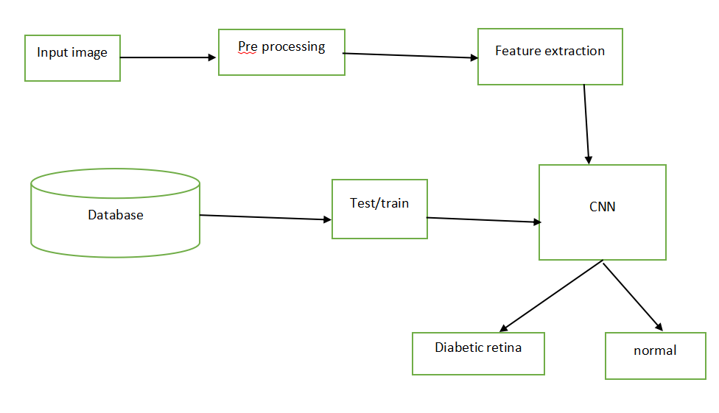

IMPLEMENTATION:
PREPROCESSING

Image Pre-processing is a common name for operations with images at the lowest level of abstraction. Its input and output are intensity images.ο The aim of pre-processing is an improvement of the image data that suppresses unwanted distortions or enhances some image features important for further processing.
Image restoration is the operation of taking a corrupted/noisy image and estimating the clean original image. Corruption may come in many forms such as motion blur, noise, and camera misfocus. Image restoration is different from image enhancement in that the latter is designed to emphasize features of the image that make the image more pleasing to the observer, but not necessarily to produce realistic data from a scientific point of view. Image enhancement techniques (like contrast stretching or de-blurring by a nearest neighbor procedure) provided by "Imaging packages" use no a priori model of the process that created the image. With image enhancement noise can be effectively be removed by sacrificing some resolution, but this is not acceptable in many applications. In a Fluorescence Microscope resolution in the z-direction is bad as it is. More advanced image processing techniques must be applied to recover the object. De-Convolution is an example of image restoration method. It is capable of: Increasing resolution, especially in the axial direction removing noise increasing contrast.

ALGORITHMS:
CONVOLUTION NEURAL NETWORK
INTRODUCTION

Convolutional neural networks. Sounds like a weird combination of biology and math with a little CS sprinkled in, but these networks have been some of the most influential innovations in the field of computer vision. 2012 was the first year that neural nets grew to prominence as Alex Krizhevsky used them to win that year’s ImageNet competition s(basically, the annual Olympics of computer vision), dropping the classification error record from 26% to 15%, an astounding improvement at the time.Ever since then, a host of companies have been using deep learning at the core of their services. Facebook uses neural nets for their automatic tagging algorithms, Google for their photo search, Amazon for their product recommendations, Pinterest for their home feed personalization, and Instagram for their search infrastructure.

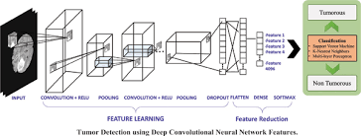
The Problem Space
Image classification is the task of taking an input image and outputting a class (a cat, dog, etc) or a probability of classes that best describes the image. For humans, this task of recognition is one of the first skills we learn from the moment we are born and is one that comes naturally and effortlessly as adults. Without even thinking twice, we’re able to quickly and seamlessly identify the environment we are in as well as the objects that surround us. When we see an image or just when we look at the world around us, most of the time we are able to immediately characterize the scene and give each object a label, all without even consciously noticing. These skills of being able to quickly recognize patterns, generalize from prior knowledge, and adapt to different image environments are ones that we do not share with our fellow machines.

Inputs and Outputs
When a computer sees an image (takes an image as input), it will see an array of pixel values. Depending on the resolution and size of the image, it will see a 32 x 32 x 3 array of numbers (The 3 refers to RGB values). Just to drive home the point, let's say we have a color image in JPG form and its size is 480 x 480. The representative array will be 480 x 480 x 3. Each of these numbers is given a value from 0 to 255 which describes the pixel intensity at that point. These numbers, while meaningless to us when we perform image classification, are the only inputs available to the computer. The idea is that you give the computer this array of numbers and it will output numbers that describe the probability of the image being a certain class (.80 for cat, .15 for dog, .05 for bird, etc).

What We Want the Computer to Do
Now that we know the problem as well as the inputs and outputs, let’s think about how to approach this. What we want the computer to do is to be able to differentiate between all the images it’s given and figure out the unique features that make a dog a dog or that make a cat a cat. This is the process that goes on in our minds subconsciously as well. When we look at a picture of a dog, we can classify it as such if the picture has identifiable features such as paws or 4 legs. In a similar way, the computer is able perform image classification by looking for low level features such as edges and curves, and then building up to more abstract concepts through a series of convolutional layers. This is a general overview of what a CNN does. Let’s get into the specifics.

Biological Connection
But first, a little background. When you first heard of the term convolutional neural networks, you may have thought of something related to neuroscience or biology, and you would be right. Sort of. CNNs do take a biological inspiration from the visual cortex. The visual cortex has small regions of cells that are sensitive to specific regions of the visual field. This idea was expanded upon by a fascinating experiment by Hubel and Wiesel in 1962 (Video) where they showed that some individual neuronal cells in the offense and non-offense responded (or fired) only in the presence of edges of a certain orientation. For example, some neurons fired when exposed to vertical edges and some when shown horizontal or diagonal edges. Hubel and Wiesel found out that all of these neurons were organized in a columnar architecture and that together, they were able to produce visual perception. This idea of specialized components inside of a system having specific tasks (the neuronal cells in the visual cortex looking for specific characteristics) is one that machines use as well, and is the basis behind CNNs.

Structure
Back to the specifics. A more detailed overview of what CNNs do would be that you take the image, pass it through a series of convolutional, nonlinear, pooling (downsampling), and fully connected layers, and get an output. As we said earlier, the output can be a single class or a probability of classes that best describes the image. Now, the hard part is understanding what each of these layers do. So let’s get into the most important one.

First Layer – Math Part
The first layer in a CNN is always a Convolutional Layer. First thing to make sure you remember is what the input to this conv (I’ll be using that abbreviation a lot) layer is. Like we mentioned before, the input is a 32 x 32 x 3 array of pixel values. Now, the best way to explain a conv layer is to imagine a flashlight that is shining over the top left of the image. Let’s say that the light this flashlight shines covers a 5 x 5 area. And now, let’s imagine this flashlight sliding across all the areas of the input image. In machine learning terms, this flashlight is called a filter(or sometimes referred to as a neuron or a kernel) and the region that it is shining over is called the receptive field. Now this filter is also an array of numbers (the numbers are called weights or parameters). A very important note is that the depth of this filter has to be the same as the depth of the input (this makes sure that the math works out), so the dimensions of this filter is 5 x 5 x 3. Now, let’s take the first position the filter is in for example. It would be the top left corner. As the filter is sliding, or convolving, around the input image, it is multiplying the values in the filter with the original pixel values of the image (aka computing element wise multiplications). These multiplications are all summed up (mathematically speaking, this would be 75 multiplications in total). So now you have a single number. Remember, this number is just representative of when the filter is at the top left of the image. Now, we repeat this process for every location on the input volume. (Next step would be moving the filter to the right by 1 unit, then right again by 1, and so on). Every unique location on the input volume produces a number. After sliding the filter over all the locations, you will find out that what you’re left with is a 28 x 28 x 1 array of numbers, which we call an activation map or feature map. The reason you get a 28 x 28 array is that there are 784 different locations that a 5 x 5 filter can fit on a 32 x 32 input image. These 784 numbers are mapped to a 28 x 28 array.

First Layer – High Level Perspective
However, let’s talk about what this convolution is actually doing from a high level. Each of these filters can be thought of as feature identifiers. When I say features, I’m talking about things like straight edges, simple colors, and curves. Think about the simplest characteristics that all images have in common with each other. Let’s say our first filter is 7 x 7 x 3 and is going to be a curve detector. (In this section, let’s ignore the fact that the filter is 3 units deep and only consider the top depth slice of the filter and the image, for simplicity.)As a curve detector, the filter will have a pixel structure in which there will be higher numerical values along the area that is a shape of a curve (Remember, these filters that we’re talking about as just numbers!).

CONCLUSION:
The results reflect the reliability and accuracy of CNN and mark the areas of excellence of the model. The integral focus of our study was centered on the amount of data and the accuracy of the results. Methods involving statistical methods, machine learning methods, and deep learning have already been discovered, capable of performing accurately. However, all the existing methods either require the user to perform some manual tasks for processing, or they may not function properly under the deficit of a large dataset.
REFERENCE:
1. Hua, Cam-Hao; Kim, Kiyoung; Huynh-The, Thien; You, Jong In; Yu, Seung-Young; Le-Tien, Thuong; Bae, Sung-Ho; Lee, Sungyoung (2020). Convolutional Network with Twofold Feature Augmentation for Diabetic Retinopathy Recognition from Multi-modal Images. IEEE Journal of Biomedical and Health Informatics, (), 1–1. doi:10.1109/jbhi.2020.3041848
2. C. I. Serrano, V. Shah, and M. D. Abràmoff, ‘‘Use of expectation disconfirmation theory to test patient satisfaction with asynchronous telemedicine for diabetic retinopathy detection, ’’Int. J. Telemed. Appl., vol. 2018, pp. 1–14, Oct. 2018.
3. American Academy of Ophthalmology, ‘‘International clinical diabetic retinopathy disease severity scale detailed table, ’’Amer. Acad. Ophthalmol., San Francisco, CA, USA, Tech. Rep., 2002
4. International Diabetes Federation. IDF Diabetes Atlas 7th edn (International Diabetes Federation, Brussels, Belgium, 2015).
5. Roychowdhury, Sohini; Koozekanani, Dara D.; Parhi, Keshab K. (2014). DREAM: Diabetic Retinopathy Analysis Using Machine Learning. IEEE Journal of Biomedical and Health Informatics, 18(5), 1717– 1728. doi:10.1109/jbhi.2013.2294635
6. Dai, Ling, et al. “A Deep Learning System for Detecting Diabetic Retinopathy across the Disease Spectrum.” Nature News, Nature Publishing Group, 28 May 2021, www.nature.com/articles/s41467-021- 23458-5.
7. Goodfellow, Ian & Pouget-Abadie, Jean & Mirza, Mehdi & Xu, Bing & Warde-Farley, David &
8. Ozair, Sherjil & Courville, Aaron & Bengio, Y.. (2014). “Generative Adversarial Networks." Advances 9. in Neural Information Processing Systems. 3. 1
10. [Dataset] Porwal, P.; Pachade, S.; Kamble, R.; Kokare, M.; Deshmukh, G.; Sahasrabuddhe, V.; Meriaudeau, F. Indian Diabetic Retinopathy Image Dataset (IDRiD): A Database for Diabetic Retinopathy Screening Research. Data 2018, 3, 25. https://doi.org/10.3390/data3030025
11. “Proposed international clinical diabetic retinopathy and diabetic macular edema disease severity scales,” Ophthalmology, vol. 110, no. 9, pp. 1677 – 1682, 2003.
12. Li, Xiaomeng; Hu, Xiaowei; Yu, Lequan; Zhu, Lei; Fu, Chi-Wing; Heng, Pheng-Ann (2019). CANet: Crossdisease Attention Network for Joint Diabetic Retinopathy and Diabetic Macular Edema Grading. IEEE Transactions on Medical Imaging, (), 1–1. doi:10.1109/TMI.2019.2951844
13. Abdurrazaq, Ibrahim; Hati, Subhas; Eswaran, C. (2008). [IEEE 2008 International Conference on Computer and Communication Engineering (ICCCE) - Kuala Lumpur, Malaysia (2008.05.13-2008.05.15)] 2008 International Conference on Computer and Communication Engineering - Morphology approach for features extraction in retinal images for diabetic retinopathy diagnosis. (), 1373– 1377. doi:10.1109/iccce.2008.4580830

